**Mobile App 2 Project**

**Name:** Cian Doyle

**Student ID:** G00335783

**E-Mail:** [G00335783@gmit.ie](mailto:G00335783@gmit.ie)

**Introduction**

For my 3rd year Mobile Application Development project I will be doing a top down shooter game. The game will be cross platform application that uses C# and visual studio which will work on android.

In the game the player will go from the menu to the main level and try and survive for as long as they can racking up the highest score they can.

**Design**

On the applications launch, the screen will show a starting menu with the options to Play, About or Quit. The play button will launch the game itself and will load up a level. If the player is starting a new game

The About button will have a short description of what the game is about.

Finally, the Quit button will exit the application.

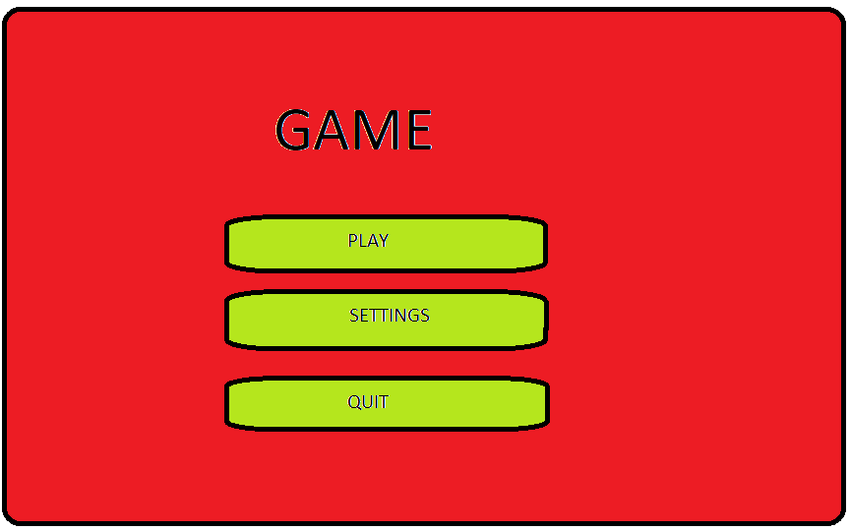

Figure 1: Start Screen

**Level Design**

For the level design it will be a Tiled floor with 4 walls and the players score on the top of the level scene. Each time the player shoots an enemy the score will go up by one. There is no limit and will keep going till the player dies.

The player will not have a health bar. The player has 5 chances before he dies and the player flashes red when he is it so it can be seen if you’ve been hit. Once the player has been hit a fifth time a game over text will appear on the screen.

The controls for the game will be the w, a, s, d keys to move the character. The aim will be controlled by the mouse.

Pressing down the left mouse button will be used to shoot from the character. The player will have to manoeuvre around the limited space to avoid the enemies and shoot at the same time. Which becomes more difficult as more enemies appear.

5 enemies will spawn every half a second at the start and throughout the game. The game is an endless run, so it just keeps spawning enemies until your player dies.

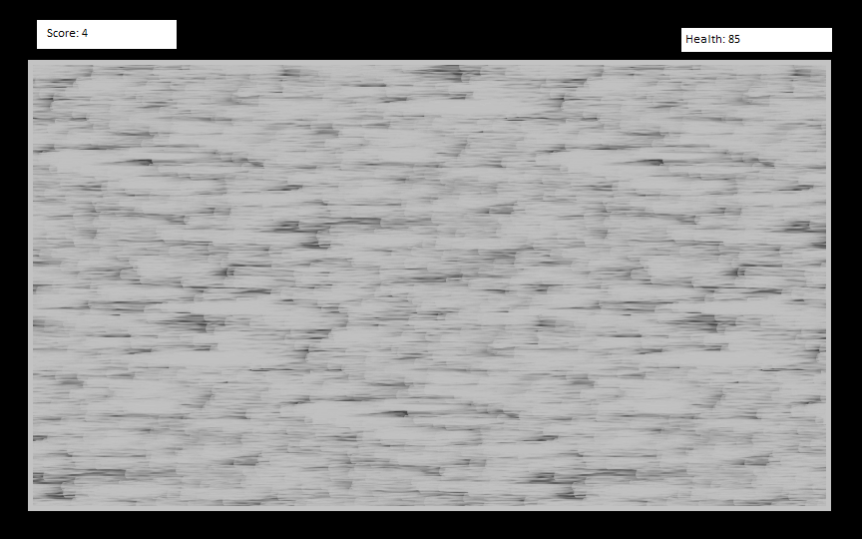

Figure 2: Level Design

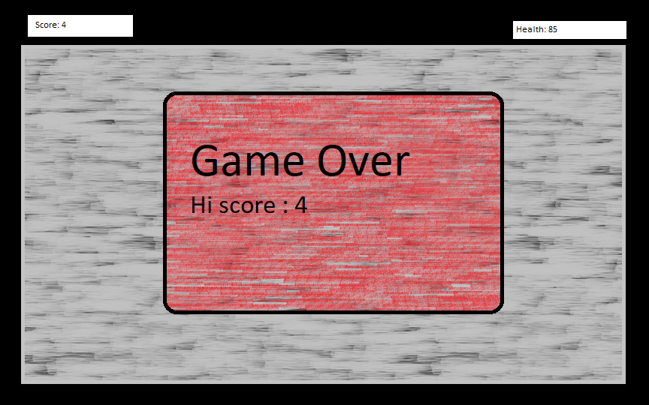

Figure 3: Game Over Screen

**Objects**

The game will consist of the Player Character, the enemies and also a light source that follows the player around as it moves. The player character will have a health of a max 5 hits he can take. The enemy does a 1 hit damage for each strike.

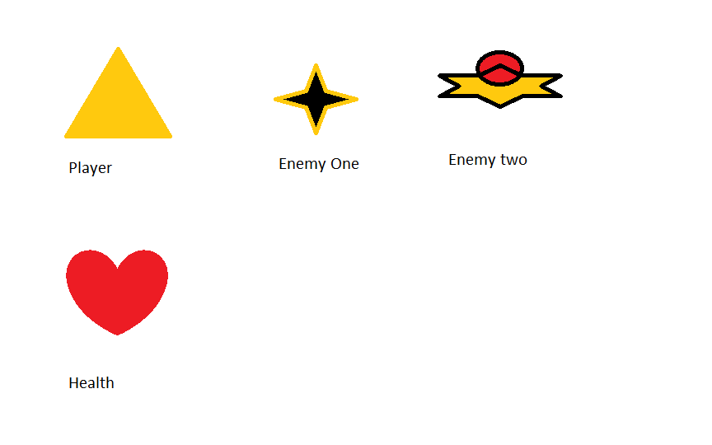

Figure 4: Game Objects

**Conclusion**

By the end of this project I hope to have a fully functioning and fun mini game which will challenge the player and make the player want to continuously try and best their own high score. I hope I will learn a lot in the process of making this as well.